**2013**

**FENCING**

**CHAMPIONSHIP**



**NORTHEAST REGIONAL**

***PARTICIPANT MANUAL***

**HOSTED BY…**



**TABLE OF CONTENTS**

**Tournament Personnel 3**

**General Information 4**

Artificial Noise Maker4

Coaches Meeting 4

Concessions 4

Championship Start Time 4

Credentials 4

Directions 4

Eligibility 4

Entry Fee 5

Equipment 5

Facility Information 5

Hospitality 5

Host Rotation 5

Hotel Information 5

Locker Room Facilities 6

Media Relations 6

Medical Information 6

Merchandise 6

Officials 6

Parking 6

Participants 7

Post Game Meal 7

Prohibited Items/Actions 7

Registration 8

Set-Up 8

Tailgating 8

Transportation 8

**Format 9**

**Hospital Directions 10**

**Directions to Campus 10**

**Map of Campus 11**

**Public Transportation 12**

**Points of Local Interest 13**

**Invoice 14**

**PERSONNEL**

**Championship Director**

LJ Holmgren (M) 646-261-6059

(O) 718-990-1663

**Championship Manager**

Maciej Siekierski (O) 718-990-5951

**Administration**

John Diffley (M) 917-567-1179

Senior Associate Director of Athletics (O) 718-990-6836

Kemi Bamishe................................................................................ (O) 718-990-6858

**Head Coach**

Yury Gelman (O) 718-990-5027

**Media Relations**

Ryan Gilbert (M) 212-203-2965

(O) 718-990-1523

**Sports Medicine**

Alex Ambrose (O) 718-990-6198

**Tickets**

Christine Fleming (O) 718-990-6874

**Athletic Facilities**

Daniel Hagenlocher (O) 718-990-3419

**Merchandise**

Daniel Hagenlocher (O) 718-990-3419

**GENERAL INFORMATION**

**Artificial Noisemakers**

No artificial noisemakers will be permitted at any NCAA postseason events.

**Coaches Meetings**

A meeting for coaches and administrators will be held on **Saturday, March 9 at 5:30 p.m.** in the President’s Room. The meeting is mandatory for all head coaches of participating teams.

**Concessions**

Concessions will be available at Carnesecca Arena under Sections 1-5.

**Championship Start Time**

Competition will begin approximately 30 minutes after the close of registration.

**Credentials**

All requests for media credentials should be made to Ryan Gilbert of Sports Communication. Any other credential requests for Visiting Administrators should be made to the Championship Director, LJ Holmgren. St. John’s will provide credentials to the following parties:

* Media
* Committee Representatives
* Officials
* VIPs

The credentials will be provided to each participating team’s administrator or coach at the coaches meeting on Saturday, March 9th at 5:30 p.m.

**Directions**

For a complete list of directions to the St. John’s Campus and Carnesecca Arena please see page 11 and for a map of campus see page 12.

**Eligibility**

NE Region entry limit = 10 total student-athletes/gender with a maximum of 4 student-athletes/gender/weapon. The names of the individual entries must be emailed to Ryan Gilbert at [Ryan.gilbert@stjohns.edu](mailto:Ryan.gilbert@stjohns.edu) and to each member of the NCAA Regional Fencing Committee listed below by March 5, 2013. Each fencer must meet the NCAA qualifying criteria listed in the <http://www.ncaa.org/wps/myportal/ncaahome?WCM_GLOBAL_CONTEXT=/ncaa/ncaa/sports+and+championship/fencing/national+collegiate/index+-+nc+fencing>. You will need to create a username and login.

**NCAA Northeast Regional Committee:**

Barb Bolich (Chair)

Massachusetts Institute of Technology

[bbolich@mit.edu](mailto:bbolich@mit.edu)

Bruce Gillman

Vassar College

[brgillman@vassar.edu](mailto:brgillman@vassar.edu)

Syd Fadner

Boston College

[sydney.fadner@bc.edu](mailto:sydney.fadner@bc.edu)

Dr Thomas Vrabel

Sacred Heart University

[vrabelt@sacredheart.edu](mailto:vrabelt@sacredheart.edu" \t "_blank)

**Entry Fee**

The entry fee for participants will be $75.00 per fencer. Please find a copy of the invoice on page 20. Entry fee may be paid the morning of the championship. A receipt for the fee is available.

**Equipment**

USFA equipment rules apply and will be strictly enforced. There will be a full equipment check including all masks, body cords, head cords, lames, and saber over gloves. Equipment control will open at **5:30 pm on Saturday, March 9th** and at **7:30 am on Sunday, March 10th** in Carnesecca Arena basement.

**Facility Information**

The 2013 NCAA Fencing Northeast Regional will be hosted by St. John’s at the Carnesecca Arena located in Queens, NY on **Sunday, March 10, 2013.** For the facility diagram see page 10 and for the facility set up see page 11.

**Hospitality**

All Access, Media and VIP credential holders may take advantage of hospitality in the Carnesecca Arena President’s Room located under Section 12 in the main arena.

**Host Rotation**

For planning purposes, here are the locations of the Regional’s for the next eight years. Please be sure your athletic administration knows of this responsibility.

|  |  |
| --- | --- |
| Year | Host |
| 2013 | St. John’s University |
| 2014 | Wellesley College |
| 2015 | New York University |
| 2016 | Yeshiva University |
| 2017 | Yale University |
| 2018 | Brandeis University |
| 2019 | Columbia University |
| 2020 | Cornell University |

**Hotel Information**

**Marriott LaGuardia**

East Elmhurst, NY 11369

Contact – Joseph D’Aquaro

516-782-0118

20-25 minutes by car to STJ

***Courtyard by Marriott/LaGuardia Holiday Inn Hotel- LaGuardia***

90-10 Grand Central Parkway 37-10 114th Street

East Elmhurst, NY 11369 Corona, NY 11368

Contact –Miguelina Flores Contact - Marie Sclafani

718-308-4743 718-906-1611

15-20 minutes by car to STJ 10-15 minutes by car to STJ

**Locker Room Facilities**

General public locker rooms are available for visiting teams. Personal belongings should not be left in the general locker room area. A designated team bag drop area will be assigned for each team. St. John’s does not provide towels; visiting teams are responsible for supplying their own.

In addition to sports medicine coverage an Ambulance will be provided by Corona Volunteer.

**Merchandise**

NCAA Merchandise will be for sale throughout the entire day (9:00 am – 6:00 pm). Payment can be made by cash only.

**Officials**

Officials should report to the Carnesecca Arena President’s Room for an officials meeting at 8:00 a.m. prior to the start of the event.

**Parking**

**Team Parking**

Visiting fencing teams are instructed to park along The Soccer Stadium in front of Carnesecca Arena. Please refer to the campus map on page 12.

**Participants**

Boston College

Brandeis University

Brown University

City College of New York

Columbia University

Cornell University

Harvard University

Hunter College

Mass. Institute Technology

New York University

Queens College

Sacred Heart University

St. John’s University

Tufts University

Vassar College

Wellesley College

Yale University

Yeshiva University

**Meal Information**

Visiting fencing teams are asked to have their post-game meals delivered to their bus.

**Queens** **Manhattan**

**Subway Stout NYC**

176-71 Union Turnpike 133 West 33rd Street

Fresh Meadows, NY 11366 New York, NY 10001

718-380-8718 212-629-6191

**Qdoba Mexican Grill Social Bar & Grill**

61-40 188th St . 795 8th Ave. (@49th St.)

Fresh Meadows, NY 11365 NY, NY 10019

718-454-9400 212-459-0643

**Applebee’s Mustang Harry’s**

61-48 188th street 352 7th Ave. (@30th St.)

Fresh Meadows, NY 11365 New York, NY 10061

718-264-1222 212-268-8930

**Double J Deli Feile**

168-02 Union Turnpike 131 West 33rd st.

Fresh Meadows, NY 11366 New York, NY 10061

718-380-3515 212-695-1122

**Regina’s Pizza Energy Kitchen**

176-49 Union Turnpike 18 West 23rd st.

Fresh Meadows NY 11366 New York, NY 10010

718-591-5727 212-989-2323

**Dante's Restaurant (Italian) Latitude Bar & Grill**

168-12 Union Turnpike 783 8th Ave. (@48th St.)

Flushing, NY 11439 New York, NY 10019

718-380-3340 212-245-3034

**Sly Fox Inn (American) Uncle Jack’s Steakhouse**

177-23 Union Turnpike 440 9th Ave.

Flushing, NY 11439 New York, NY 10001

718-969-8169 212-244-0005

**Registration/Check In**

Participant registration will open on **Sunday, March 10 at 7:00 a.m.** and will take place in the Carnesecca Arena Lobby. Registration will close at the following times:

8:30 a.m. Women’s Saber

8:30 a.m. Women’s Epee

10:30 a.m. Men’s Epee

10:30 a.m. Men’s Foil

11:00 a.m. Women’s Foil

1:00 p.m. Men’s Saber

**Set-Up**

Teams will have access to the facility from **5:00PM until 9:00PM on Saturday March 9, 2013** in order to set up their scoring equipment.

**Tailgating**

Please note that tailgating is NOT permitted on the St. John’s campus during fencing events.

**Team Equipment**

St. John’s will confirm equipment with each school. Teams unable to provide the required equipment may be asked to assist schools bringing additional equipment with set up. Contact LJ Holmgren [farinal@stjohns.edu](mailto:farinal@stjohns.edu) or Maciej Siekierski [siekierm@stjohns.edu](mailto:siekierm@stjohns.edu) at St. John’s if you have any questions.

Each team must bring the following equipment, all in excellent working order:

1 – metallic strip with grounding wire

2 – three-weapon scoring machines with time and score

4 – reels

4 – floor cords

2 – extension cords (at least 16 feet)

1 – stop watch

2 – sets of shims,

2 – foil weights

2 – épée weights

**FORMAT**

All quarterfinals will have 35 fencers (unless there are less than 35 entries), all semifinals will have 21 fencers, and all finals will have 12 fencers, as follows:

Quarterfinals= 5 pools of 7: 21 advance

Semifinals= 3 pools of 7: 12 advance

Finals= 1 pool of 12

Whenever possible, pools of 7 will be fenced on two strips. The final pool will be fenced on two or more strips. In order to get to the quarterfinals of 35, there will be a “Play in Competition.” Using the chart below, when the number of present entries equals the number in the “**# of Fencers**” column, the fencers who are seeded as shown in the “**Seeds**” column will fence using the format in the “**Format**” column. Each format in the chart will yield enough fencers to be added to the higher seeds so that 35 fencers remain.

|  |  |  |
| --- | --- | --- |
| **# of Fencers** | **Seeds** | **Format** |
| 36 | 32-36 | 1 pool of 5: 4 up |
| 37 | 33-37 | 1 pool of 5: 3 up |
| 38 | 29-38 | 2 pools of 5: 7 up |
| 39 | 30-39 | 2 pools of 5: 6 up |
| 40 | 31-40 | 2 pools of 5: 5 up |
| 41 | 27-41 | 3 pools of 5: 9 up |
| 42 | 28-42 | 3 pools of 5: 8 up |
| 43 | 24-43 | 4 pools of 5: 12 up |
| 44 | 25-44 | 4 pools of 5: 11 up |
| 45 | 26-45 | 4 pools of 5: 10 up |
| 46 | 22-46 | 5 pools of 5: 14 up |
| 47 | 23-47 | 5 pools of 5: 13 up |
| 48 | 19-48 | 6 pools of 5: 17 up |
| 49 | 20-49 | 6 pools of 5: 16 up |
| 50 | 21-50 | 6 pools of 5: 15 up |
| 51 | 16-51 | 7 pools of 5: 20 up |
| 52 | 17-52 | 7 pools of 5: 19 up |
| 53 | 18-53 | 7 pools of 5: 18 up |
| 54 | 14-54 | 8 pools of 5: 22 up |
| 55 | 15-55 | 8 pools of 5: 21 up |
| 56 | 16-56 | 8 pools of 5: 20 up |
| 57 | 12-57 | 9 pools of 5: 25 up – 5 pools of 5: 24 up |
| 58 | 13-58 | 9 pools of 5: 25 up – 5 pools of 5: 23 up |
| 59 | 14-59 | 9 pools of 5: 25 up – 5 pools of 5: 22 up |
| 60 | 15-60 | 9 pools of 5: 25 up – 5 pools of 5: 21 up |

**FACILITY DIAGRAM**

**FACILITY SET UP –Carnesecca Arena**

**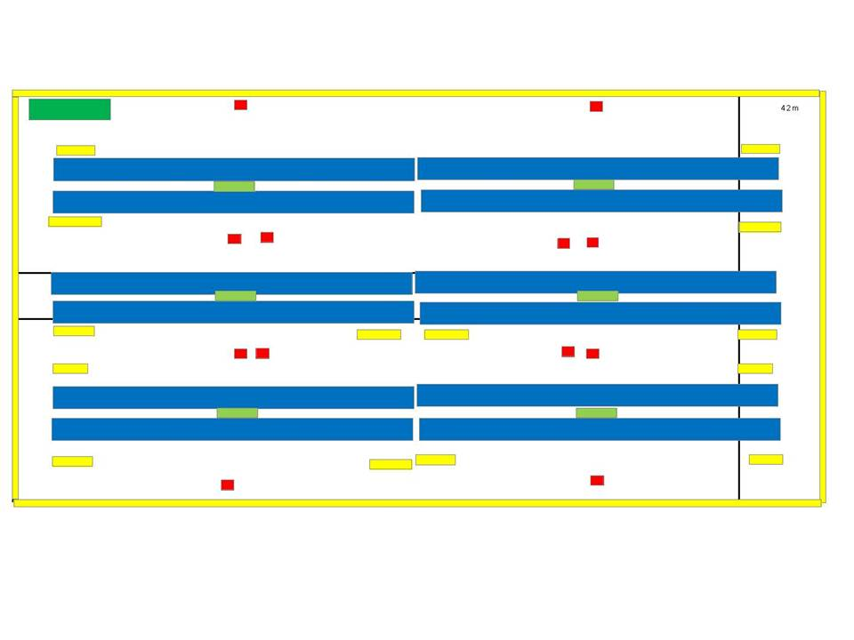**

**FACILITY SET UP –Taffner Field House**

**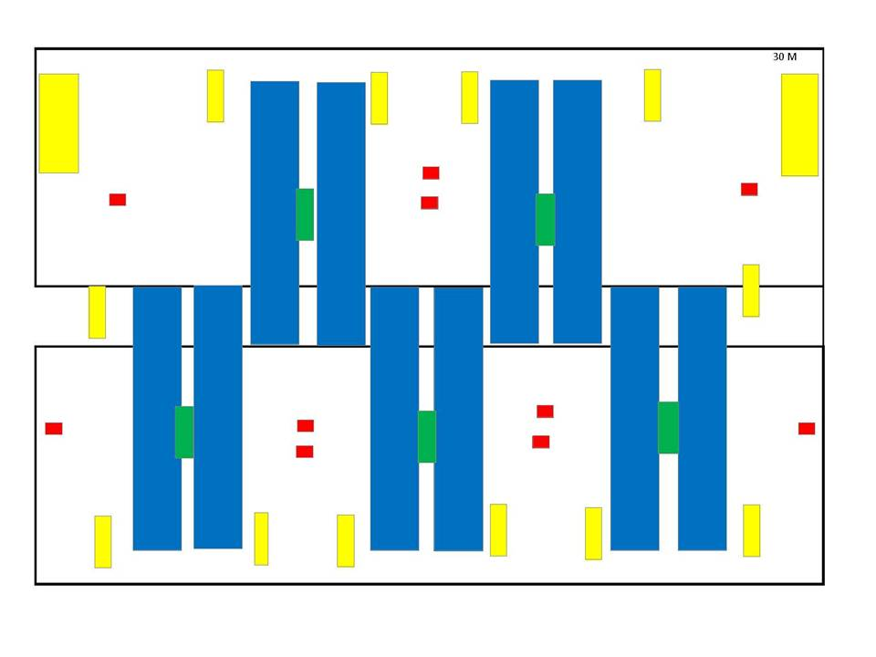**

**EMERGENCY INFORMATION**

**Phone Numbers**

**St. John’s Campus Safety**: 718.990.6281 (*From a campus phone dial: 6281)*

**HOSPITAL DIRECTIONS**

|  |  |  |  |  |
| --- | --- | --- | --- | --- |
| **Hospital:** | |  |  | |
| New York Hospital of Queens | |  |  | |
| 56-45 Main Street, Flushing, NY | |  | | |
| 718-670-1100 | |  | |  |
|  | |  | |  |
| **Additional Emergency Telephone Numbers:** | | | |  |
| Queens Medical Center |  | | |  |
| 82-68 164th Street, Jamaica, NY |  | | |  |
|  | | | | |
| **Directions from team hotels to New York Hospital of Queens** | | | | |
| \*\* All hotels are in the same general area and can follow these directions \*\*  1. Head northwest on Ditmars Blvd ( 364 ft)  2. At the traffic circle, continue straight to stay on Ditmars Blvd (0.3 miles)  3. Turn right onto the Grand Central Pkwy E ramp to Eastern Long Island (0.2 miles)  4. Merge onto Grand Central Pkwy (2.3 miles)  5. Take exit 10E for Interstate 495 E toward Eastern Long Island (0.3 miles)  6. Follow signs for I-495 E and merge onto I-495 E (1.0 miles)  7. Take exit 23 toward Main Street ( 499 ft)  8. Merge onto Horace Harding Expy (0.2 miles)  9. Turn left onto Main Street (0.4 miles)  10. Destination will be on the right | | | | |
| **Directions from Carnesecca Arena to New York Hospital of Queens** | | | | |
| 1. Leaving from Gate 4, turn right on Union Turnpike  2. At first light, make left on Utopia Parkway  3. Turn left onto Horace Harding Expy (495 Service Road) (1.81 miles)  4. Turn right onto Main Street  5. Destination will be on the right (0.3 miles) | | | | |

**DRIVING DIRECTIONS TO MAIN CAMPUS**

GPS Address: - 8000 Utopia Parkway, Queens, NY, 11439

**By Automobile:**

**From Manhattan:** Queens Midtown Tunnel to the Long Island Expressway. Exit at Utopia Parkway. Stay on the service road to Utopia Parkway and turn right. Follow Utopia Parkway to Union Turnpike. Campus is on the right.

**From Brooklyn:** Either the Belt Parkway (east) to Van Wyck Expressway (678 N). Exit at Main Street/Union Turnpike. Proceed to the third traffic light. Make a right onto Grand Central Parkway service road to Utopia Parkway. Turn left and the campus will be on the left; **OR** The Jackie Robinson Parkway (east) to the Grand Central Parkway (east). Exit at Utopia Parkway. Turn left and the campus will be on the left.

**From the Bronx:** Take the Throgs Neck Bridge to the Clearview Expressway. Exit at Union Turnpike and make a right. Follow to Utopia Parkway. Campus is on the left; **OR** take the Triboro Bridge to Grand Central Parkway. Exit at Utopia Parkway, turn left at light. Campus is on the left.

**From Long Island: (North) -** Take the Northern State Parkway to the Grand Central Parkway and exit at 188th Street. Turn left at the light and make an immediate right onto the service road. Follow the service road to Utopia Parkway, bear right onto Utopia Parkway. Campus is on the left. OR Take Long Island Expressway (west) to Clearview Expressway (south) ten exit at Union Turnpike. Bear right onto Union Turnpike to Utopia Parkway. Make a left, then a right onto campus.

**From Long Island: (South) -** Take Southern State Parkway to Cross Island Parkway (north) to Grand Central Parkway (west). Exit at 188th Street. Follow above directions to campus.

**By Public Transportation:**

**I.N.D. Subway**: “**E**” or “**F**” train to Kew Gardens/Union Turnpike. Then take the **Q46** bus to Utopia Parkway and Union Turnpike.

**I.R.T. Subway**: “**7**” train to Main Street, Flushing. Then take the **Q17** bus to Utopia Parkway and Long Island Expressway. Transfer to the **Q30** or **Q31** bus to 82nd Avenue and Utopia Parkway.

**Long Island Railroad**: L.I.R.R. to Jamaica Station. Then take the **Q30** or **Q31** bus to 82nd Avenue and Utopia Parkway.

**MAP OF ST. JOHN’S MAIN CAMPUS**

GPS Address: - 8000 Utopia Parkway, Queens, NY, 11439



**POINTS OF LOCAL INTEREST**

**Manhattan**

**Madison Square Garden Tours The Museum of Modern Art**

Between 31st and 33rd Streets on 11 W. 53rd Street

7th Avenue 212-708-9510

212-465-5800

**Empire State Building**

**Circle Line Sightseeing Cruise** 34th Street and Fifth Avenue

Pier 83 212-736-3100

West 43rd Street at Hudson River

212-563-3200 **United Nations**

45th Street and First Avenue

**American Museum of Natural History** 212-415-4000

Central Park West at 79th Street

212-769-5200 **South Street Seaport**

South & Fulton Streets Pier 16

**Statue of Liberty** 212-732-8257

Liberty Island

New York Harbor **AMC Loews**

212-363-3200 Lincoln Square (13 with IMAX)

West 68th Street & Broadway

**Coach USA Gray Line Tours** 212-336-5000

800-669-0051

**Queens**

**St. Patrick's Cathedral American Museum of the**

Fifth Avenue and 50th Street **Moving Image**

212-753-2261 36-01 35th Avenue

718-784-0077

**Radio City Music Hall**

Sixth Avenue at 50th Street **Bronx**

212-247-4777 **The Bronx Zoo**

Fordham Road & Bronx

**Guggenheim Museum** River Parkway

1071 Fifth Avenue at 88th Street 718-367-1010

212-423-3500

**INVOICE**

|  |  |  |  |
| --- | --- | --- | --- |
| |  | | --- | |  | |  | INVOICE |
|  |  |  |
|  |  |  |
|  | **DATE:** |  |
|  | **INVOICE #** | NCAA Regional |
|  | **FOR:** | *Registration Fee* |
| **Entry Fee = $75.00 Per Participant** |  |  |
|  |  |  |
| **Remit Payment To:** |  |  |
| **St. John’s University** |  |  |
| Attn: Athletic Business Office |  |  |
| 8000 Utopia Parkway |  |  |
| Queens, NY, 11439 |  |  |
|  |  |  |
|  |  |  |
|  |  |  |
| **DESCRIPTION** | | **AMOUNT** |
| # of Participants X $75.00 = | |  |
|  | |  |
|  | |  |
|  | |  |
|  | |  |
|  | |  |
|  | |  |
|  | |  |
|  | |  |
|  | **TOTAL** | $ - |
|  |  |  |
|  |  |  |
| Make all checks payable to **St. John’s University** |  |  |
| If you have any questions contact or email Mike Barry: [barrym@stjohns.edu](mailto:barrym@stjohns.edu) (718) 990-6221 | | |

Three (3) entries per weapon per team plus one (1) additional entry in a single weapon is permitted with a maximum of ten (10) fencers per gender. The names of the individual entries must be emailed to Ryan Gilbert at [Ryan.gilbert@stjohns.edu](mailto:Ryan.gilbert@stjohns.edu) and to each member of the NCAA Regional Fencing Committee listed below by March 5, 2012. Each fencer must meet the NCAA qualifying criteria listed in the <http://www.ncaa.org/wps/myportal/ncaahome?WCM_GLOBAL_CONTEXT=/ncaa/ncaa/sports+and+championship/fencing/national+collegiate/index+-+nc+fencing>